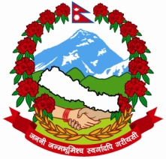
Government of Nepal

Ministry of Physical Infrastructure and Transport
Department of Railways

Rail, Metrorail and Monorail Development Project
Date of Notice Publication: July 12, 2017

Following consultants have been Short Listed for Feasibility Study of Electrified Railway Line for Kathmandu – Birgunj as per notice published for Expression of Interest (EOI) for the above consultancy service in the Kathmandu Post Daily on 03rd December, 2016.

Name of the Consulting Firms
- Cheil Engineering Co., Ltd. J/V with Korea Railroad Corporation International Consultant and Technocrats Pvt. Ltd. And Association with Sustainable Infrastructure Development Foundation
- China Railway First Survey and Design Institute Group Co., Ltd., DOHWA Engineering Co. Ltd., SILT Consultant Pvt. Ltd. In association with Tech Studio of Engineering
- SOOSUNG Engineering Co., Ltd., Pyunghwa Engineering Consultants Ltd. And Korea Engineering Consultants Corp. in association with WeKreate International Pvt. Ltd. And Material Test Pvt. Ltd.
- J/V of Yooshin Engineering Corporation and Korea Railroad Research Institute and Full Bright Consultancy Pvt. Ltd.
- Third Railway Survey and Design Institute Group Corporation and TRACTEBEL Engineering Pvt. Ltd.
- China Railway SIYUAN Survey and Design Group Co., Ltd.

Director General

